PANDEMIC PREPAREDNESS PLAN
ARATTUPUZHA LSG

MESSAGE FROM PRESIDENT/CHAIR LSGI

Dear Residents
As the President of the Arattupuzha Grama Panchayat, I reaffirm our strong commitment to protecting the health and well-being of every member of our community. Public health is a shared responsibility, and our local self-government is dedicated to ensuring safe, healthy, and resilient living conditions for all families, especially in areas that face environmental challenges.
Arattupuzha is a beautiful coastal area with a narrow strip of land between the sea and backwaters, making it uniquely vulnerable to natural hazards such as coastal erosion, strong waves, flooding, and related risks to infrastructure and homes. This geographical vulnerability means we must take extra care in planning, preparedness, and response to protect lives and livelihoods.
In response, the Panchayat will work actively with health workers, disaster volunteers, women’s self-help groups, youth organizations, and all residents to promote hygiene, early warning systems, safe drinking water, sanitation, and community health awareness. Your participation is essential. Together we can build stronger disaster resilience and healthier living environments.
Nestled between the vast expanse of the Arabian Sea and the serene backwaters lies the slender strip of land that forms the fourteen wards of Arattupuzha Grama Panchayat. Five further wards stretch gently along the shores of the Kayamkulam Lake.
The inhabitants of Arattupuzha dwell constantly upon a knife-edge of peril: relentless sea erosion, ferocious storm surges, treacherous king tides, the sudden fury of rogue waves known as kallakkadal, devastating cyclones, and a host of other menacing threats. In the face of such ever-present dangers, unceasing vigilance is not merely advisable it is essential.
I urge every individual, household, institution, and community group to cooperate with the guidelines, take part in health and safety programs, and support our collective efforts to safeguard public health and resilience. Let us work hand-in-hand to make Arattupuzha a model of proactive, inclusive, and community driven development.
Thank you.

12/01/2026 Arattupuzha Gramapanchayat president
Maimoonath Fahad
Arattupuzha


MESSAGE FROM HEALTH STANDING COMMITTEE CHAIR

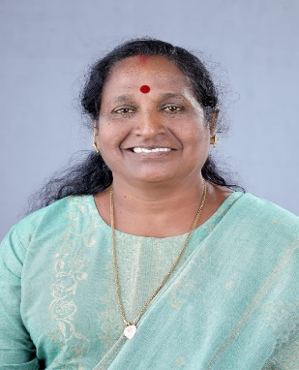

As Chairperson of the Health Standing Committee, Arattupuzha Grama Panchayat, I wish to reaffirm our Local Self Government’s strong commitment to public health and community well-being. Our Panchayat faces unique challenges due to its coastal location, high population density, and history of natural disasters. Protecting the health of every resident is our highest priority.
This Pandemic Preparedness Plan is a collective effort, designed to ensure that our community is ready to respond quickly and effectively to any health emergency. We recognize that success depends not only on government action, but also on the active participation of every resident, family, and local organization. By working together—health workers, volunteers, self-help groups, and all stakeholders—we can build a safer, healthier environment for everyone.
I urge all residents to follow the guidelines in this plan, participate in health and safety programs, and support our efforts to improve hygiene, early disease detection, and disaster preparedness. Let us remain vigilant, cooperate with each other, and take responsibility for our shared future. Together, we can make Arattupuzha a model of community-driven public health and resilience.
THANK YOU

Health Standing Committee Chairperson
14/01/2026
Arattupuzha

MESSAGE BY MEDICAL OFFICER
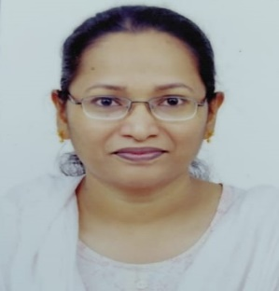
Arattupuzha is particularly vulnerable to a spectrum of health threats, including vector-borne diseases like dengue and leptospirosis, water-borne illnesses such as acute diarrheal disease and hepatitis A,Heat related diseases and respiratory infections. These risks are intensified by frequent flooding, coastal erosion, and saline intrusion, which can compromise water quality and sanitation. Our elderly, children, and occupationally exposed groups especially fisherfolk are at heightened risk of severe illness and complications.
Early surveillance is the foundation of effective public health action. By closely monitoring disease trends, environmental hazards, and unusual health events, we can detect outbreaks at their earliest stages and respond swiftly. Our surveillance system integrates facility-based reporting, community level monitoring by ASHA workers and volunteers, and event-based triggers such as school absenteeism and animal health alerts. This layered approach enables rapid case identification, contact tracing, and targeted interventions, helping to contain transmission and protect our most vulnerable residents.
No single department can address the complex challenges posed by pandemics and environmental disasters especially in a coastal context. Our preparedness plan is built on strong intersectoral coordination, bringing together the Health Department, Local Self Government, Fisheries, Water Authority, Veterinary Services, Disaster Management, and other key sectors. During any outbreak or disaster, this collaborative approach ensures:
Our mission is to provide timely, highquality, and equitable healthcare to every resident of Arattupuzha, regardless of circumstance. The Pandemic Preparedness Plan reflects our unwavering commitment to public health, resilience, and inclusive development. Through continuous surveillance, coordinated interdepartmental response, and empowered community participation, we are building a safer, healthier future for all.
Let us stand together health workers, local leaders, volunteers, and every resident to uphold the highest standards of public health and disaster preparedness. Your co-operation and vigilance are essential to our shared success.
Thank you

Dr.Sherin.M
MO,FHC Arattupuzha

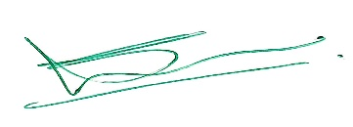
12/01/2026
Arattupuzha

EXECUTIVE SUMMARY

Family Health Centre (FHC) functions as the primary public healthcare institution serving the population of 32,782 Grama Panchayath. The PHC plays a pivotal role in delivering comprehensive, accessible, and affordable healthcare services, with a strong focus on preventive, promotive, curative, and rehabilitative care in accordance with national and state health programmes.
The FHC caters to a predominantly rural population, addressing key public health priorities such as maternal and child health, communicable and non-communicable disease control, immunization, family welfare, adolescent health, and geriatric care. Regular outpatient services, home-based care through field health staff, and outreach activities ensure healthcare coverage even in geographically challenging areas. The institution actively implements national health missions, including the National Health Mission (NHM), National Tuberculosis Elimination Programme, National Programme for Prevention and Control of Cancer, Diabetes, Cardiovascular Diseases and Stroke (NPCDCS), and other disease surveillance initiatives.
Arattupuzha FHC works in close coordination with the Grama Panchayath, ASHA workers, Anganwadi centres, schools, and community-based organizations to strengthen community participation and improve health awareness. Emphasis is placed on early detection, timely referral, health education, and lifestyle modification to reduce disease burden and improve overall health outcomes.
Despite constraints related to infrastructure, manpower, and increasing service demand, the PHC continues to enhance service delivery through effective planning, data-driven decision-making, and community engagement. Strengthening facilities, upgrading digital health systems, and expanding preventive services remain key focus areas for future development.
Overall, Arattupuzha Family Health Centre stands as a vital institution in safeguarding public health and improving the quality of life of the residents of Arattupuzha Grama Panchayath

LIST OF ABBREVIATIONS

LSGD/LSGI | Local Self Government Department / Local Self Government Institution
BMO | Block Medical Officer
IDSP | Integrated Disease Surveillance Programme
NDMA | National Disaster Management Authority
PPE | Personal Protective Equipment
ICMR | Indian Council of Medical Research
CD | Communicable Diseases
NCD | NON-COMMUNICABLE Diseases

TABLE OF CONTENTS

3
INTRODUCTION 9
● Background of the PPP 9
LSGD AT A GLANCE 9
INTEGRATED HEALTH INFRASTRUCTURE MAP OF ____________ PANCHAYAT 10
GENERAL PROFILE OF THE LSGI’S 13
Background of the LSGI 13
Demographic and Vulnerable Population 14
Clinical Vulnerability 16
INFRASTRUCTURE & RESOURCE INVENTORY 18
Health Facility Directory & Basic Capacity in the LSGD 18
Private Clinics 19
Healthcare Education & Training Institutions 20
Specialized Services & Emergency Inventory 20
Oxygen & Diagnostic Capacity 21
Diagnostics facility mapping at the LSGI level 22
Laboratory Identification & Basic Details 22
Social and Community Infrastructure for surge plan 22
Human resources 24
Community & Support Cadre 25
Community Organizations 26
Administrative & Emergency Services 27
Information regarding resources 27
ONE HEALTH & ENVIRONMENTAL SURVEILLANCE 28
Animal & Bird Population 28
Veterinary Infrastructure 29
Veterinary Doctors & Workforce 30
High-Risk Interface Points (Surveillance Sites) 30
Environmental Risk Mapping 31
Disease Seasonality Mapping 32
Vulnerability Mapping 33
EPIDEMIOLOGICAL TRENDS (2021–2025) 34
Disease Burden among human beings(Last 5 Years) 34
*(use the above table data to create the graph/diagram) 36
Seasonal Trend Analysis 37
Outcome-Based Trend Analysis- 2025 39
Transmission Trend- 2025 40
Integrated Disease Hotspot Map (2021–2025) 42
Preparedness and Response Protocol at LSG Level 44
Constitution of One Health Committee 44
Pandemic Response Workforce 45
Activities and Measures before and during Pandemic 47
PHASE 1 - Alert / Preparation 47
PHASE 2 - Active Response 50
Standard Screening Protocol 51
PHASE 3 - Surge Capacity 60
Conversion of Community Facilities 60
CONCLUSION 61
RECOMMENDATIONS 62
ANNEXURE 63
1. IMPORTANT PHONE NUMBERS 63

1.INTRODUCTION
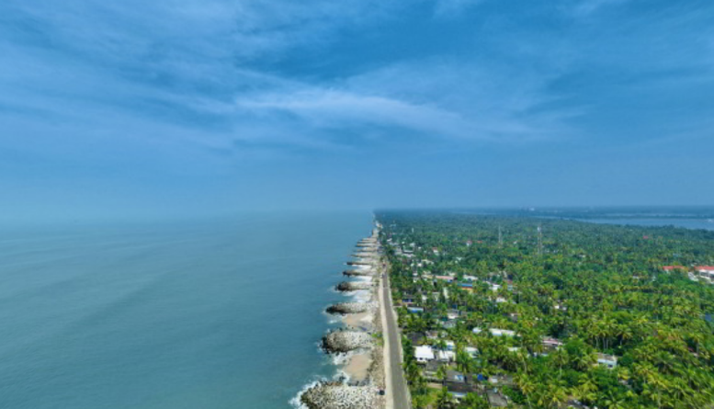
Images:1.1 view of Arattupuzha
This document serves as a strategic roadmap for the Arattupuzha Grama Panchayat to navigate the complex intersection of public health emergencies and natural disasters. Given its unique coastal geography and history of calamities, the document transitions the local administration from a reactive stance to a state of permanent readiness.
Baseline for Rapid Mobilization
The plan establishes a ‘ready-to-act’ framework. By documenting existing resources such as the FHC, five sub-centres, and the workforce the Panchayat can activate emergency protocols without the delay of administrative searching. This is vital for a region where one river, 54 ponds, and 117 wells create a landscape that can quickly become a breeding ground for water-borne diseases during floods.
Arattupuzha has a high population density (1,444 persons/sq. km) with a workforce largely dependent on informal, climate-exposed sectors like fishing and coir work. This document:
- Maps Vulnerabilities: Identifies elderly persons, children, and fisherfolk as priority groups.
- Pinpoints Shortages: Analyzes current deficiencies in health infrastructure, logistics (like ambulances or medical supplies), and surveillance systems to ensure that during an outbreak of Leptospirosis or Dengue, the response is not hampered by lack of equipment.
Convergence of Government, Private, and AYUSH Sectors
The document recognizes that a single department cannot manage a major disaster. It provides a formal structure for Pluralistic Health Coordination, bringing together the Government (FHC), Private clinics, and AYUSH (Ayurveda/Homeopathy) hospitals. This ensures that during a surge in patients, all medical facilities work under a unified command, optimizing bed availability and medical expertise.
The history of Arattupuzha Grama Panchayat is marked by significant environmental and public health crises—ranging from the catastrophic 2004 Tsunami and Cyclone Ockhi (2017) to the devastating Monsoon Floods of 2018-19 and the COVID-19 pandemic each underscoring the vital necessity of interdepartmental convergence. These incidents demonstrate that while individual departments like Health or Fisheries provide specialized expertise, a positive outcome is only achievable when they operate in a synchronized "Single Command" structure. For instance, managing seasonal Leptospirosis cases requires the Health Department's surveillance to be paired with the LSGD’s sanitation efforts and the Water Authority’s purification of the 117 local wells. Similarly, during the Ockhi crisis, the integration of the Coast Guard's rescue operations with AYUSH-led mental health counseling for bereaved families showcased how multi-sectoral cooperation can address both immediate physical safety and long-term community resilience.
Geographical Context & Baseline Data
Arattupuzha's geography is its greatest risk factor. As a low-lying coastal strip (22.7 sq. km) in Alappuzha, it is effectively a water-locked region during high tides or heavy rains. The Orange Book of Disaster Management emphasizes that for such coastal LSGIs, the convergence of the Fisheries Department (for rescue boats) and the Health Department (for mobile medical units) is the most critical link in saving lives.

LSGD AT A GLANCE
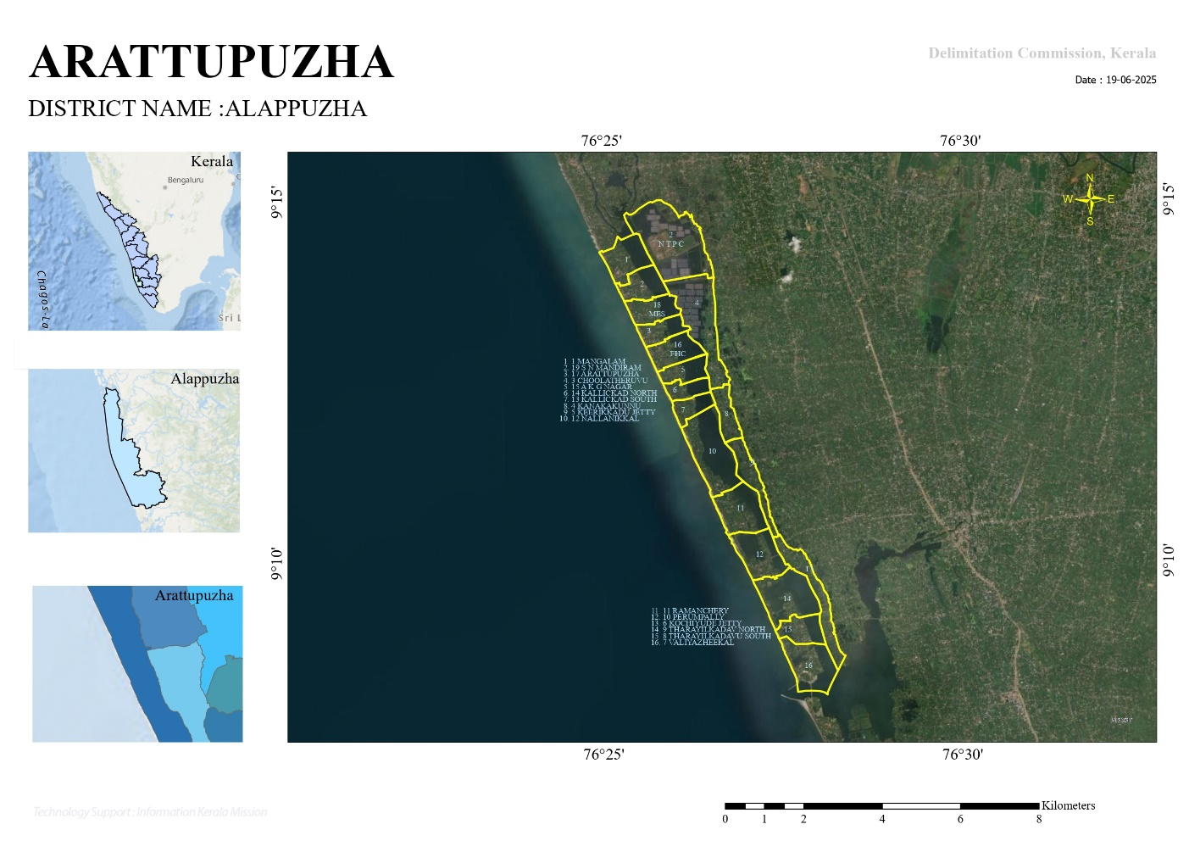
1.2 image of Geographical boundaries with political map (based on latest delimitation)

Panchayat Overview and Geographical Profile
Arattupuzha Grama Panchayat is situated in the Karthikappally Taluk of Alappuzha District, under the Muthukulam Block. Geographically, it is uniquely positioned between the Arabian Sea to the west and the Kayamkulam Kayal (backwaters) to the east. The Panchayat shares its southern border with Alappatt Panchayat in Kollam District and its eastern borders with the Panchayats of Kandalloor, Muthukulam, Chingoli, and Karthikappally. The administrative structure comprises 18 wards, with 14 wards located between the sea and the backwaters, and 4 wards situated on the eastern bank of the Kayamkulam Kayal.
Baseline and Ward Demographics
The Panchayat's baseline data reflects a significant population concentrated within its 18 wards. Based on the provided records, the key statistics at a glance are as follows:
- Total Wards: 18
- Total Houses: 9,666
- Total Population: 32,782
- Educational Institutions: 18
- Healthcare Facilities (Govt/Pvt):
- Wells: 117
Socio-Economic and Occupational Patterns
The primary livelihood for the residents of Arattupuzha is fishing, which serves as the backbone of the local economy. In addition to the fisheries sector, a portion of the population is engaged in agriculture, animal husbandry, and coir spinning. Notably, the Panchayat has demonstrated administrative excellence, achieving national recognition in 2018 for the best implementation of the Mahatma Gandhi National Rural Employment Guarantee Scheme (MGNREGS).
Vulnerability and Risk Stratification
Due to its coastal location, the region is highly vulnerable to various natural hazards and climate-related risks. Historical data indicates that the area has been impacted by significant disasters, including the 2004 Tsunami, Cyclone Ockhi, and the 2018 floods. Key geographic vulnerabilities include:
- Water-related Hazards: The Panchayat is prone to flooding, waterlogging, and coastal erosion (sea surges).
- Climate Risks: Increasing instances of extreme rainfall, lightning, and potential for communicable disease outbreaks are identified as critical risk areas.
- Infrastructural Landmarks: Major developments like the Valiyazheekkal Bridge and the five-faced lighthouse serve as critical infrastructure points for the region.

Maps - ward-based (Mention source also)

- Geographical boundaries - ward boundaries map
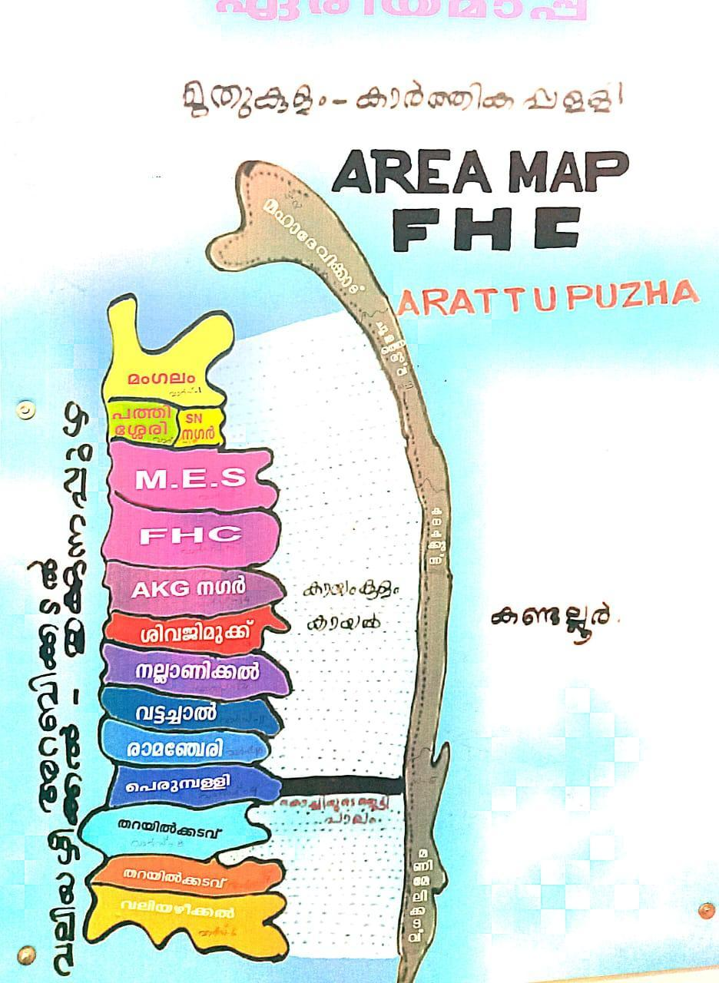
Image 1.3 Areamap of Arattupuzha LSGD
Ward 1 (Vattachal): North: Thrikkunnapuzha Panchayat; South: Ward 2; East: Kayamkulam Kayal; West: Arabian Sea.
Ward 2 (Kallikkadu): North: Ward 1; South: Ward 3; East: Kayamkulam Kayal; West: Arabian Sea.
Ward 3 (Arattupuzha North): North: Ward 2; South: Ward 4; East: Kayamkulam Kayal; West: Arabian Sea.
Ward 4 (Arattupuzha): North: Ward 3; South: Ward 5; East: Kayamkulam Kayal; West: Arabian Sea.
Ward 5 (Arattupuzha South): North: Ward 4; South: Ward 6; East: Kayamkulam Kayal; West: Arabian Sea.
Ward 6 (Perumpally): North: Ward 5; South: Ward 7; East: Kayamkulam Kayal; West: Arabian Sea.
Ward 7 (Mangalam): North: Ward 6; South: Ward 8; East: Kayamkulam Kayal; West: Arabian Sea.
Ward 8 (Mahadevikadu North): North: Ward 7; South: Ward 9; East: Kayamkulam Kayal; West: Arabian Sea.
Ward 9 (Mahadevikadu): North: Ward 8; South: Ward 10; East: Kayamkulam Kayal; West: Arabian Sea.
Ward 10 (Puthiyavila West): North: Ward 9; South: Ward 11; East: Kayamkulam Kayal; West: Arabian Sea.
Ward 11 (Valiyazheekkal): North: Ward 10; South: Alappad Panchayat (Kollam District); East: Kayamkulam Kayal; West: Arabian Sea.
Ward 12 (Kandalloor North): North: Muthukulam Panchayat; South: Ward 13; East: Kandalloor Panchayat; West: Kayamkulam Kayal.
Ward 13 (Kandalloor South): North: Ward 12; South: Ward 14; East: Kandalloor Panchayat; West: Kayamkulam Kayal.
Ward 14 (Puthiyavila East): North: Ward 13; South: Devikulangara Panchayat; East: Kandalloor Panchayat; West: Kayamkulam Kayal.
Ward 15 (Ramanchery): North: Thrikkunnapuzha Panchayat; South: Ward 16; East: Karthikappally Panchayat; West: Kayamkulam Kayal.
Ward 16 (Pullukulangara): North: Ward 15; South: Ward 17; East: Karthikappally Panchayat; West: Kayamkulam Kayal.
Ward 17 (Pathiyankara): North: Ward 16; South: Ward 18; East: Muthukulam Panchayat; West: Kayamkulam Kayal.
Ward 18 (Kizhakkeakkara): North: Ward 17; South: Muthukulam Panchayat; East: Muthukulam Panchayat; West: Kayamkulam Kayal

INTEGRATED HEALTH INFRASTRUCTURE MAP OF ARATTUPUZHA PANCHAYAT

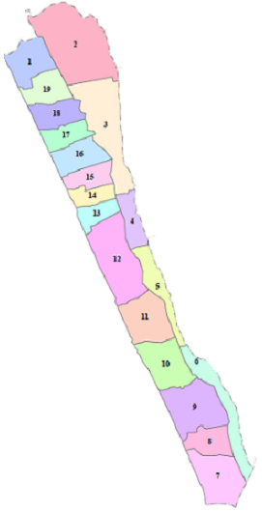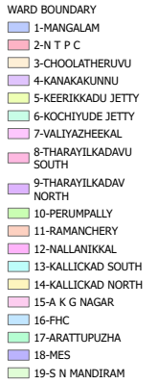

Health Infrastructure Map

GENERAL PROFILE OF THE LSGI’S

Background of the LSGI
Arattupuzha Grama Panchayat is situated in the Karthikappally Taluk of Alappuzha District, within the Muthukulam Block. Geographically, it is uniquely positioned between the Arabian Sea to the west and the Kayamkulam Kayal (backwaters) to the east. The Panchayat is administratively divided into 18 wards (updated data is 19 wards); 14 of these wards are located on the coastal strip between the sea and the backwaters, while 4 wards are situated on the eastern bank of the Kayamkulam Kayal.
Its administrative boundaries are as follows:
- North: Thrikkunnapuzha Panchayat.
- South: Alappatt Panchayat in Kollam District.
- East: Kandalloor, Muthukulam, Chingoli, and Karthikappally Panchayats.
- West: Arabian Sea.
Socio-Economic Background
The primary livelihood of the residents is fishing, which serves as the backbone of the local economy. In addition to fisheries, significant portions of the population are engaged in:
- Agriculture and allied activities.
- Animal Husbandry.
- Coir Spinning and coconut husk processing.
The Panchayat has also achieved notable administrative success, having secured first place nationally in 2018 for its implementation of the Mahatma Gandhi National Rural Employment Guarantee Scheme (MGNREGS).
Historical Vulnerability and Resilience
Located in a disaster-prone coastal region, Arattupuzha has historically faced several major crises, including the 2004 Tsunami, Cyclone Ockhi, and the COVID-19 pandemic. The region is highly susceptible to:
- Coastal Hazards: Sea surges and coastal erosion.
- Seasonal Flooding: Particularly during monsoon periods.
- Public Health Risks: Communicable diseases such as Dengue and Leptospirosis are noted concerns in the context of climate change.
Despite these challenges, infrastructure projects like the Valiyazheekkal Bridge and the unique five-faced lighthouse have become significant landmarks, contributing to the region's visibility and development. The current 2023–2024 Disaster Management Plan aims to integrate these local realities into a data-driven framework for enhanced community resilience.
Table 1: Background of LSGD
Item | Details
Name of LSGI | Arattupuzha
Type (GP/Municipality etc.) | Gramapanchayat
Block | Muthukulam
District | Alappuzha
Number of wards | 19
Total area (sq. km) | 22.7 sq km
Population (latest) | 32782
Population density | 1444 persons/sq km
Terrain (coastal/low-lying/backwaters/foothills, etc.) | Coastal
Number of rivers passing through LSGI | 1
Number of ponds in the LSGI | 22
Number of wells in LSGI | 117

Demographic and Vulnerable Population
Understanding the demographic composition and vulnerable population groups is essential for pandemic preparedness. Children, elderly, economically deprived families, migrant workers, and socially vulnerable groups are at increased risk during public health emergencies due to higher exposure, limited access to services, and dependency on public systems..

Description | Details (in numbers)
DEMOGRAPHIC PROFILE
Total population | 32782
Male | 15928
Female | 16854
Transgender | 0
Children under 0-6 | 1354
Adolescent | 3389
Elderly (>60) | 5628
SOCIAL/LIVELIHOOD VULNERABILITY
Description | Details (in numbers)
DEMOGRAPHIC PROFILE
EPEP family | 103
BPL family | 4451
Tribal communities | 0
SC | 611
Migration | 90
Fisherfolk | 6150

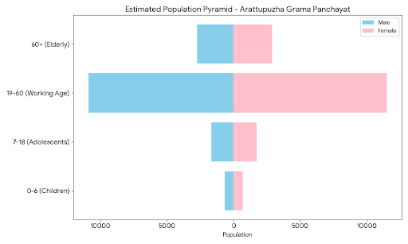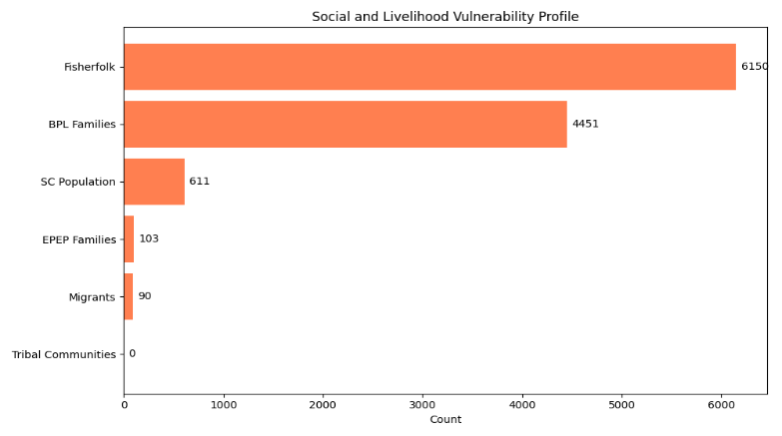
Graphs: 1 Population pyramid for seeing if your LSGI has a high "dependency ratio" (lots of children and elderly compared to working adults). Graphs: 2 Social and Livelihood Vulnerability profile.

Clinical Vulnerability
Certain population groups needs priority healthcare & are at higher risk of severe illness, complications, and mortality during pandemics. Patients with chronic diseases, those requiring regular medical care, and individuals with mobility or functional limitations face challenges in accessing timely care during emergencies. Mapping these groups helps in prioritizing continuity of treatment, medicine stock planning, oxygen support, referral transport, and targeted home-based care.
Description | Details
Pregnant women | 102
Lactating mothers | 495
Bedbound patients | 80
Patients under palliative care other than bedbound | 124
Patients on Haemodialysis | 21
CAPD patients | 19
Cancer patients | 29
Haemophilic patients | 4
Mentally challenged | 83
Differently abled | 97
Diabetic patients | 2512
Hypertensive patients | 4518
TB patients | 6

Major Festivals & Events specific to the LSGI
(with the possibility of a public gathering)
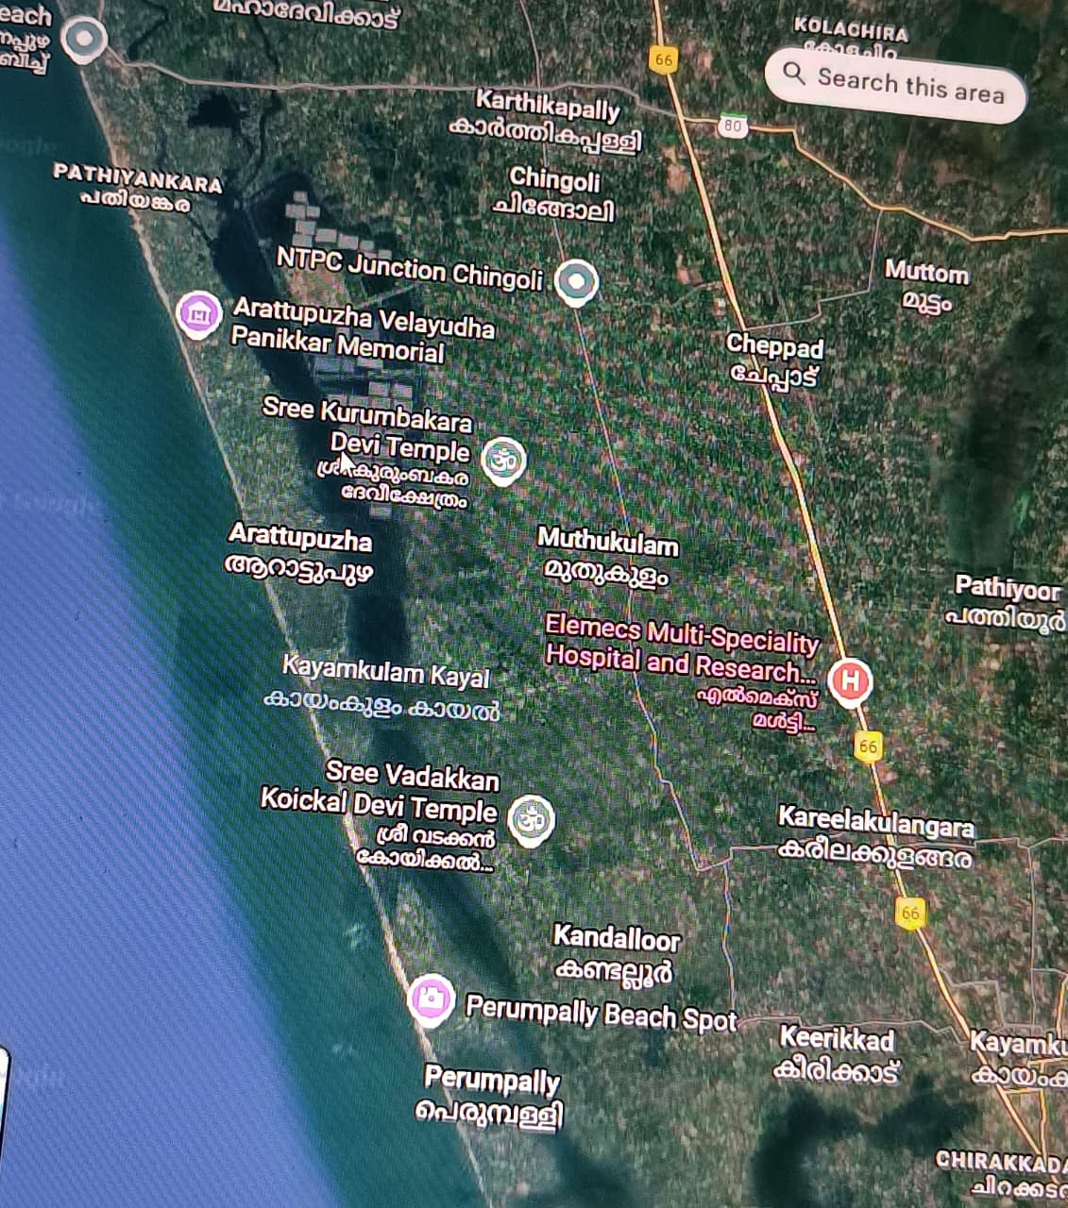

Sl. No. | Ward No. | Ward Name | Major Site / Festival | Month | Primary Public Health Risks
1 | 1 | Vattachal | Mangalam Shivrathri / Local Shrines | February | Overcrowding, free food supply, coastal water-logging.
2 | 2 | Venpuzha | Venpuzha Church (Valiya/Cheriya Perunal) | Feb & April | Mass gathering, sanitation pressure, food safety.
3 | 3 | Kallikkadu | Kallikkadu Temple Area | March-April | Significant crowding; requires zoonotic & food surveillance.
4 | 7 | Valiyazheekkal | Thaippooyam (Subrhamanya Swami Temple) | January | Extreme overcrowding, massive food distribution.
5 | 8 | Arattupuzha North | Arattupuzha Temple (Arattu) / Tharayilkadav | March-April | High risk of water-borne diseases; river/sea proximity.
6 | 12 | Ramanchery | Local Mosques & Temples | Seasonal | High population density; waste management challenges.
7 | 13/14 | Valiyazheekkal | Karkkidaka Vavu Bali / Shivanadai | July / March-April | High Risk: Inter-district movement from Kollam; coastal transit.
8 | 16 | Perumpally | Perumpally Church & Temple | Seasonal | Dense coastal settlement; risk of respiratory/vector spread.
9 | 17 | AC Palli | AC Palli Annual Function | January | Large congregation in a localized area; food safety risk.
10 | 18 | Mangalam | Local Temples | Seasonal | Low-lying area; susceptible to flood-related Leptospirosis.
11 | 19 | Patheesherril | Meenabharani | March-April | Overcrowding, intensive food supply management needed.

INFRASTRUCTURE & RESOURCE INVENTORY

Health Facility Directory & Basic Capacity in the LSGD
This section provides an overview of the healthcare infrastructure available within the LSGD area. It outlines the distribution and basic capacity of health facilities that form the backbone of service delivery during routine times and public health emergencies.

Family Health Centres (FHCs) and Community Health Centres (CHCs) generally function as the first point of contact for the community, providing essential outpatient and inpatient services. General Hospitals (GH) and Medical College Hospitals (MCH), where accessible, serve as the main referral centres for advanced diagnostics, specialist care, and critical services during public health emergencies. This inventory helps identify existing strengths, gaps, and potential surge capacity that can be mobilised during a pandemic or disaster.
Sl.  no. | Health Facility | Type of Facility  (MCH/GH/C HC/FHC/SC  etc.) | Contact Number | Total beds | ICU  Beds | Oxygen- Supporte d Beds | No. of Ventilator Support | No. of ambulances
Government Healthcare Facilities
1 | ARATTUPUZHA | FHC | 944785632 | 24 | 0 | 0 | 0 | 0
2 | ARATTUPUZHA MAIN | AAM |  | 0 | 0 | 0 | 0 | 0
3 | MANGALAM | AAM |  | 0 | 0 | 0 | 0 | 0
4 | KANAKAKKUNNU | AAM |  | 0 | 0 | 0 | 0 | 0
5 | ARATTUPUZHA SOUTH | AAM |  | 0 | 0 | 0 | 0 | 0
6 | ARATTUPUZHA NORTH | AAM |  | 0 | 0 | 0 | 0 | 0
7 | GFD | DISPEN | 8281559117 | 0 | 0 | 0 | 0 | 0
Private Healthcare Facilities
1 | RV | Clinic | 7034624888
2 | Madathil | Clinic

Table 5. Health Facility Resource Summary
AYUSH Healthcare Facilities
1 | Gov Ayurveda Dispensary.  Pathissery,  Arattupuzha | Dispensary | 0479-2480474 | - | - | - | - | -
2 | Gov.Homeo c,Tharayilkkadavu,Ward-9 | Dispensary | 04792489110 | - | - | - | - | -

Private Clinics
Private clinics are an essential part of pandemic preparedness, as they are often the first place people seek care when symptoms begin. In many communities, private clinics manage a significant share of outpatient visits and therefore play a critical role in early case detection, timely referrals, and disease surveillance. Having an up-to-date understanding of where these clinics are located, the services they provide, and how they are linked to the public health system helps ensure that no cases are missed during an outbreak. It also allows health authorities to engage private practitioners more effectively for reporting, risk communication, and coordinated response, strengthening the overall capacity of the health system to manage public health emergencies.

Table 6. Private Clinic Resource Summary
Sl No. | Name of Clinic | Registered (Y/N) | Clinic (General / Specialty) | Specialty (if any) | Address | Contact Number | Diagnosti c Facility (Y/N) | Ambulanc e Linkage (Y/N)
1 | RV Clinic | Y | Special clinic | CHILD SPE. | Dr.Lathika  Ward-4 | 7034624888 | N | N
2 | MADATHIL Clinic | N | Special clinic | ENT |  |  | N | N

Healthcare Education & Training Institutions
This section tracks the educational infrastructure available, which is vital for human resource planning in the health sector.

Category of Institution | Govt | Private | AYUSH | Total
Medical Colleges | 0 | 0 | 0 | 0
Nursing Colleges | 0 | 0 | 0 | 0
Dental Colleges | 0 | 0 | 0 | 0
Para-medical / Allied Health | 0 | 0 | 0 | 0
Pharmacy Colleges | 0 | 0 | 0 | 0

Specialized Services & Emergency Inventory
This section provides a detailed view of the specialized medical resources available to the community, focusing on emergency response and critical care capabilities. This table tracks the vital assets required for managing severe illnesses and emergencies across Government, Private, and AYUSH sectors.

Item | Govt | Private | AYUSH | Total
Hospital beds | 24 | 0 | 0 | 24
Oxygen-generating systems(Y/N) | 0 | 0 | 0 | 0
Oxygen-supported beds(Numbers) | 0 | 0 | 0 | 0
Ventilator supported beds | 0 | 0 | 0 | 0
ICU beds | 0 | 0 | 0 | 0
Burns units | 0 | 0 | 0 | 0
Blood banks | 0 | 0 | 0 | 0
BLS ambulances | 0 | 0 | 0 | 0
ALS ambulances | 0 | 0 | 0 | 0
Dialysis facilities | 0 | 0 | 0 | 0
Dispensaries | 2 | 0 | 0 | 2
Medical store | 6 | 0 | 0 | 6

Oxygen & Diagnostic Capacity
Monitoring oxygen and diagnostic capacity is a critical component of public health preparedness, ensuring that the LSGD can handle both chronic care and sudden surges in respiratory or infectious diseases.
Name of Health Facility | Oxygen-gener ating System (Y/N) | Backup Oxygen Source (Y/N) | Diagnostic Facilities Available(Y/N)
 |  |  | Lab | USG | X-ray | CT/MRI | RT-PCR
Government Healthcare Facilities
FHC ARATTUPUZHA | N | Y-SILINDER- 5  Concentrate-3 | Y | N | N | N | N

Diagnostics facility mapping at the LSGI level
The diagnostic capacity of Arattupuzha G.P represents the "intelligence network" of our healthcare system. The speed and accuracy of disease identification depend entirely on the distribution and technical level of these facilities.

Item | Govt | Private | AYUSH | Total
General labs | 1 | 5 | 0 | 6
Microbiology labs | 0 | 0 | 0 | 0
RT-PCR labs | 0 | 0 | 0 | 0
USG units | 0 | 0 | 0 | 0
CT/MRI units | 0 | 0 | 0 | 0

Laboratory Identification & Basic Details
Sl.  No. | Name of Laboratory | Ownership (Govt / Private / Academic) | Address | Contact No. | 24×7  Services (Yes/No) | NABL /  Govt  Approved (Yes/No)
1 | FHC Arattupuzha | Government | Ward-16  Arattupuzha | 0479-2488201 | No | Yes
2 | Sona Lab | Pvt | Ward-16 | 8606084860 | No | N
3 | Sai Lab | Pvt | Ward-10 | 9847465873 | No | N

Social and Community Infrastructure for surge plan
This table serves as our logistics and shelter inventory. By mapping these locations, quickly we can identify where to house displaced citizens, where to set up temporary medical clinics, and how to manage the deceased with dignity during a crisis.
Category | Total Count | Ward | Est. Capacity (Persons)
Educational Institutions
Anganwadis | 40 |  | >50
Schools | 13 |  | >1000
OTHERS | 1(Madrasa) | 16 | >300
Colleges | 0 | 0 | 0
Healthcare Educational Institutions
Medical colleges (Govt/Private) | 0 | 0 | 0
Nursing colleges (Govt/Private) | 0 | 0 | 0
Dental colleges (Govt/Private) | 0 | 0 | 0
Paramedical institutes (Govt/Private) | 0 | 0 | 0
Community Gathering Spaces
Community halls | 3 | 30 | 10
Auditoriums | 1 | 15 | 17
Religious buildings | 1 | 12 | 1
Vulnerable Group Support Facility
Destitute homes | 0 | 0 | 0
Elderly homes | 1(gov) | Ward-8 | 21beds
LSGD owned other buildings | 0 | 0 | 0
Mass Fatality Management (MFM) Infrastructure
Mortuary | 0 | 0 | 0
Crematorium | 0 | 0 | 0

*refer annexure 1 for contact details

Human resources
This section focuses on the human capital available within the LSGI. In any emergency be it a pandemic, flood, or industrial accident infrastructure is only as effective as the people operating it.

Medical & Clinical Personnel
This table tracks the "Frontline" providers responsible for diagnosis, treatment, and clinical management. Narrative sentence: eg., "Total health workforce: 450 personnel, with 60% in government facilities serving as primary surge capacity." A detailed directory with the contact numbers of all workers is maintained (Annexure in 1).

Cadre | Govt (No.) | Private (No.) | Total
Doctors—Modern Medicine | 4 | 3 | 7
Doctors – AYUSH | 2 | 2 | 4
Doctors – Veterinary | 1 | 0 | 1
Doctors – Dental | 0 | 0 | 0
Nursing officers | 6 | 2 | 8
Lab technicians | 1 | 4 | 5
Optometrist | 1 | 0 | 1
Pharmacists | 2 | 2 | 4
Psychologists | 0 | 0 | 0
Counsellors | 0 | 0 | 0

Public Health & Field-Level Workforce
These individuals are the backbone of surveillance, maternal-child health, and decentralized care.
Cadre | Government/Municipal | Total
HS (Health Supervisors) | 1 | 1
HI (Health Inspectors) | 1 | 1
LHS (Lady Health Supervisor) | 1 | 1
LHI (Lady Health Inspectors) | vaccant | 0
JPHN (Jr Public Health Nurses) | 4(1-vaccant) | 3
JHI (Jr Health Inspectors) | 2(2-vaccant) | 2
MLSP (Mid-Level Service Providers) | 5 | 5
Palliative Nurses | 1 | 1
RBSK Nurses | 1 | 1
PRO | 1 | 1
Epidemiologist | 1 | 1
Data Manager | 1 | 1

Community & Support Cadre
This group represents the surge capacity of the LSGI—people who can be called upon for logistics, rescue, and specialized support.
Cadre | Number
ASHA Workers | 26
AWW (Anganwadi Workers) | 40
Emergency Medical Volunteers (Trained) | 40
Kudumbashree | 444
Purusha Swayam Sahaya Sangam | 50
Ex-Servicemen | 44
Retired Police Officers | 1
NCC/NSS Volunters | 44-spc
One Health Community Volunteers | 882
One Health Community Mentors | 126

Community Organizations
This section details the presence of community-based organisations (CBOs), non-governmental organisations (NGOs), faith-based organisations (FBOs), Kudumbashree Self-Help Groups (SHGs), and Ayalkootams within the Local Self-Government Institution (LSGI). These groups enhance grassroots mobilization, resource distribution, and support networks crucial for pandemic response and community resilience.

Category | Total Count
NGOs | 0
CBOs (Resident Associations/Libraries) | 2
FBOs | 0
Sports Club | 0
Kudumbashree SHGs/ Ayalkootams | 444

Administrative & Emergency Services
This section outlines the availability of key non-health emergency support services and infrastructure within the LSGI, which are essential for effective pandemic preparedness and response. These facilities support law enforcement, disaster response, water supply, logistics, mobility, and community-level interventions during public health emergencies.
Category | Total Count | Location
Police Stations | 0 | 0
Fire & Rescue Stations | 0 | 0
Water Pumping Points | 17
Public Distribution System (PDS)

Information regarding resources
The availability of essential transport and support resources plays a quiet but critical role in saving lives. Equipment such as ambulances, mobile mortuaries, amphibian ambulances, and motorized boats ensures that patients, samples, and healthcare teams can move swiftly—even in flooded, remote, or difficult terrains. Heavy vehicles like JCBs, cranes, tractors, and torus lorries support logistics, waste management, emergency infrastructure, and rapid conversion of spaces into care or isolation facilities. Taxis, four-wheel-drive vehicles, and trucks help maintain continuity of essential services, reach vulnerable populations, and support home-based care and supply delivery.
Means of transportation | Total Count
JCB | 2
Crane | 0
Heavy Trucks | 0
Tractor | 1
Ambulances | 1
Mobile mortuaries | 1
Boats
Taxi service | 1

Note: For specific details regarding vehicle owners and contact information, please refer to Annexure [X].

ONE HEALTH & ENVIRONMENTAL SURVEILLANCE
The One Health method integrates environmental, animal, and human health to enable proactive pandemic preparedness. Panchayat-level surveillance needs to be improved in order to detect and treat zoonotic and environmentally generated diseases early. Surveillance is strengthened through systematic assessment of animal populations, veterinary infrastructure, poultry and slaughter facilities, inter-sectoral coordination, and specialised tools like avian influenza seasonality mapping using GIS in previous outbreaks to enable predictive alerts and ward-specific sampling to support effective pandemic preparedness in high-risk areas.

Animal & Bird Population
Mapping animal and bird populations at the Panchayat level is essential for identifying and prioritising zoonotic disease hazards like rabies, avian influenza (H5N1), leptospirosis, anthrax, and Nipah-like spillover occurrences. Risk classification, targeted surveillance, vaccination planning, and early epidemic detection made feasible by comprehensive population mapping all enhance One Health-based pandemic preparedness.

Category | Item | Estimated Population
Animal Population | Livestock (Cattle/Goats/Buffalo) | >1500
 | Pet Animals (Dogs/Cats) | >2200
 | Stray Dog Population | >1000
 | Pig Farms (Number of heads) | 0
 | Small Units (Sheep / Goats – clustered) | >500
Bird Population | Poultry Units (Birds) | >1000
 | Poultry- (FOWL) | >8000
 | Wild/Migratory Birds (Observed) | -
 | Crow Mortality Events (Reported) | Ocasional

The stray dog population in market areas, fish landing sites, bus stations continues to be a substantial problem for rabies surveillance and bite prevention. There is a considerable risk of avian influenza introduction and amplification during November - December due to the seasonal presence of migratory and resident water birds near ponds/ canal / river / backwater / paddy field. Clusters of pig farms and animal shelters vulnerable to flooding further raise the risk of leptospirosis and other zoonoses mediated by the environment, especially during monsoon floods.

Veterinary Infrastructure
Veterinary institutions are a core pillar of One Health surveillance, enabling early zoonotic disease detection through vaccination, investigation of unusual animal illness or deaths, sample collection, and timely outbreak reporting. A well-mapped and responsive veterinary network strengthens coordination with human health and LSGI systems, ensuring rapid response during zoonotic events and pandemics.
Facility Type | Name of Facility | Ownership Govt / Pvt | Ward(s) | Contact number
Veterinary Dispensary | Gov Veterinary Dispensary,Arattupuzha | Gov |  | 9747332178
Veterinary Hospital / Polyclinic |  | Gov
Private Veterinary Clinics | 0 | 0 | - | -
Mobile / Emergency Vet Service (incl. night services) | 0 | 0 | 0 | 9747332178
Pet Homes / Animal Shelters | 0 | 0 | 0

Veterinary Doctors & Workforce
Early detection, diagnosis, reporting, and reaction to animal illness epidemics depend on the availability and accessibility of qualified veterinary specialists. By identifying unusual animal morbidity or mortality promptly, collecting samples promptly, and coordinating efficiently with human health and LSGI systems—especially during zoonotic outbreaks and pandemic-prone situations—a clearly defined veterinary workforce enhances One Health surveillance.

Category | Number Available | Type (Govt/Pvt) | Contact number
Government Veterinary Doctors | 1 | Gov | 9747332178
Private Veterinary Doctors
Livestock Inspectors | 1 | Gov | 9745673478
Para-veterinary Staff / Attenders | - | - | -
Contract / On-call Veterinary Support (if any) | - | - | 9747332178

Environmental Risk Mapping
Environmental risk mapping identifies monsoon/flood hotspots for vector-borne (dengue, chikungunya), water-borne (leptospirosis, diarrhoea), and zoonotic diseases in Kerala's wetlands. Systematic surveillance supports early warnings, targeted interventions, and Panchayat pandemic preparedness.
Waterborne exposure: Flood-prone areas and stagnant water bodies facilitate leptospira survival, raising leptospirosis risk.

Traditional practices: Informal slaughter and fish markets lack standardized hygiene, creating spillover opportunities.

Disease Seasonality Mapping
1, Flooding & waterlogging → amplifies leptospirosis, malaria, diarrheal diseases.
·
2, Migratory bird influx (Nov–Feb) → avian influenza risk.

3, Mosquito breeding cycles → vector-borne disease peaks in monsoon.

4, Agricultural practices → close human–animal contact in paddy fields.
Risk Factor | High-Risk Wards | Key Locations | Risk Level
Flood-prone areas | Wards 1 to 14 (Coastal strip) and 15 to 18 (Eastern bank). | Areas between the Arabian Sea and Kayamkulam Kayal; low-lying regions in Arattupuzha village. | High
Water bodies/wetlands | Wards bordering the Kayamkulam Kayal and coastal inlets. | Kayamkulam Kayal and mangrove patches at Azheekkal and Perumpally. | High
Solid waste accumulation | Market areas and densely populated coastal clusters. | Near public roads, coastal beaches, and around Resource Recovery Facilities (RRF). | Medium
Animal waste disposal issues | Wards with clustered livestock/poultry units (e.g., inland wards). | Residential backyard poultry units and small-scale cattle sheds. | Medium
Rodent infestation zones | Market areas and wards with poor waste management. | Food storage areas, markets, and near stagnant water bodies. | Medium
Industrial effluent discharge | Wards near the periphery of the panchayat bordering industrial zones. | Runoff into Kayamkulam Kayal; potential impact from seafood processing units in nearby regions. | Low/Med
Construction sites / abandoned buildings | Developing residential areas and coastal sites. | New tourism-related constructions and damaged/abandoned post-disaster structures. | Low
Poor drainage / blocked canals | Most coastal wards and low-lying agricultural areas. | Tidal influenced canals and smaller interior drainage channels connecting to the Kayal. | High
Drinking water source contamination risk | All 18 wards, particularly during monsoon and post-monsoon seasons. | Shallow and deep groundwater sources; public water supply pipes prone to saline intrusion. | High

EPIDEMIOLOGICAL TRENDS (2021–2025)

Disease surveillance is the systematic collection, analysis, and interpretation of health data for planning, implementation, and evaluation of public health practice. This section presents the disease surveillance profile of the LSGI based on routine reporting systems and outbreak investigations to identify priority diseases, seasonal patterns, and emerging public health threats.

Disease Burden among human beings(Last 5 Years)
Analysis of disease-wise data for the last five years helps identify persistent public health problems, emerging diseases, and changes in disease burden. This information supports prioritisation of prevention, preparedness, and response activities at the Panchayat level.
Disease | 2023 | 2024 | 2025 | 5-Year Total | Trend  (Increasing/S table/Decrea sing)
Dengue | 14 | 24 | 22 | 60 | Stable
Leptospirosis | 0 | 0 | 4 | 4 | Stable
Hepatitis A | 0 | 1 | 4 | 5 | Increasing
Malaria | 0 | 0 | 0 | 0 | Stable
Scrub Typhus | 1 | 0 | 0 | 1 | Decreasing
Typhoid | 0 | 0 | 0 | 0 | Stable
H1N1 | 2 | 0 | 0 | 2 | Decreasing
H3N2 | 0 | 2 | 3 | 3 | Increasing
ADD | 45 | 112 | 71 | 228 | Decreasing
Mumps | 0 | 5 | 13 | 18 | Increasing
Measles | 0 | 0 | 0 | 0 | Stable
Hepatitis B | 0 | 0 | 0 | 0 | Stable
Hepatitis C | 0 | 0 | 0 | 0 | Stable
Tuberculosis | 17 | 18 | 12 | 47 | Decreasing
Leprosy | 0 | 0 | 0 | 0 | Stable
COVID-19 | 2 | 1 | 2 | 5 | Stable

Based on the last five years of data, Acute Diarrheal Disease (ADD) is the most frequent endemic challenge, with a total of 228 cases and an average of about 76 cases annually. Dengue is the next most common, with 60 cases over five years, averaging 12 cases per year. Tuberculosis also stands out with 47 cases, averaging 9 cases per year. The trend for ADD is variable but consistently the highest, while Dengue shows a slight increase and Tuberculosis remains relatively stable.

Seasonal Trend Analysis
Seasonal analysis helps anticipate surges (e.g. dengue in monsoon, leptospirosis after floods, influenza in cooler months) and plan pre‑emptive vector control, stockpiling of IV fluids, and awareness campaigns at Panchayat level.

DENGUE
Dengue is a major seasonal vector-borne disease strongly associated with rainfall, water stagnation, and increased mosquito breeding during the monsoon period.

Peak: July–November

Dengue – Ward-wise Yearly Distribution (2021–2025)
Ward | Dengue – Ward-wise Yearly Distribution
 | 2021 | 2022 | 2023 | 2024 | 2025 | Total
 |  | 1 | 1 | 5 | 0 | 7
 |  | 1 | 1 | 0 | 1 | 3
 |  | 0 | 2 | 1 | 2 | 5
 |  | 0 | 0 | 0 | 0 | 0
 |  | 0 | 2 | 0 | 0 | 2
 |  | 0 | 1 | 0 | 2 | 3
 |  | 0 | 0 | 2 | 0 | 2
 |  | 1 | 2 | 3 | 0 | 6
 |  | 0 | 1 | 2 | 2 | 5
 |  | 1 | 0 | 2 | 0 | 3
 |  | 1 | 0 | 0 | 2 | 3
 |  | 2 | 1 | 2 | 0 | 5
 |  | 0 | 2 | 1 | 0 | 3
 |  | 0 | 0 | 3 | 0 | 3
 |  | 0 | 1 | 0 | 1 | 2
 |  | 0 | 5 | 2 | 0 | 7
 |  | 0 | 0 | 1 | 1 | 2
 |  | 1 | 1 | 3 | 2 | 7
 |  | 0 | 0 | 0 | 0 | 0

LEPTOSPIROSIS
Leptospirosis cases are closely linked to monsoon rains, flooding, and occupational exposure, particularly in low-lying and waterlogged areas.

Peak: June - August

Leptospirosis – Ward-wise Yearly Distribution (2021–2025)

Ward
 | 2022 | 2023 | 2024 | 2025 | Total
 | 0 | 0 | 0 | 0 | 0
 | 0 | 0 | 0 | 0 | 0
 | 1 | 0 | 0 | 0 | 1
 | 0 | 0 | 0 | 0 | 0
 | 0 | 0 | 0 | 0 | 0
 | 0 | 0 | 0 | 0 | 0
 | 0 | 0 | 0 | 0 | 0
 | 0 | 0 | 0 | 1 | 1
 | 0 | 0 | 0 | 0 | 0
 | 0 | 2 | 0 | 1 | 3
 | 0 | 0 | 0 | 1 | 1
 | 1 | 0 | 0 | 1 | 2
 | 0 | 0 | 0 | 0 | 0
 | 0 | 1 | 0 | 0 | 1
 | 0 | 0 | 0 | 0 | 0
 | 1 | 0 | 0 | 0 | 1
 | 0 | 1 | 0 | 0 | 1
 | 0 | 0 | 0 | 0 | 0
 | 0 | 0 | 0 | 0 | 0

Outcome-Based Trend Analysis- 2025
 | Type of disease | Age group | Gender |  | Total no. of  survival | Total no. of death | No. of cases received  treatment
 |  |  | No. of Male | No. of Female
1 | Dengue | under 05 children | 1 | 0 | 1 | Nil | 1
2 |  | 5-19 years | 1 | 1 | 2 | Nil | 2
3 |  | 20-59 years | 9 | 3 | 12 | Nil | 12
4 |  | 60+ (Seniors) | 2 | 1 | 3 | Nil | 3
1 | Lepto | under 05 children | 0 | 0 | 0 | Nil | 0
2 |  | 5-19 years | 1 | 0 | 1 | Nil | 1
3 |  | 20-59 years | 3 | 0 | 3 | Nil | 3
4 |  | 60+ (Seniors) | 0 | 0 | 0 | Nil | 0

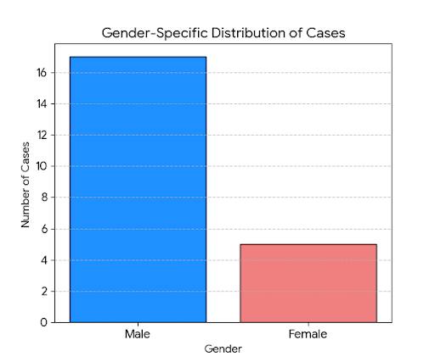
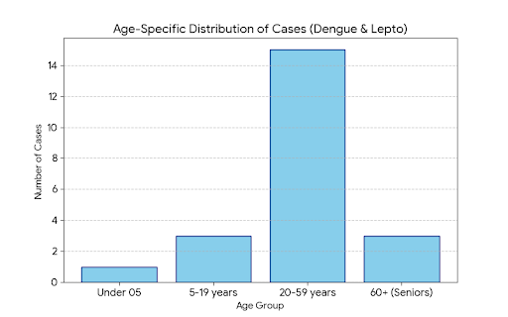

Transmission Trend- 2025
For effective management of public health issues, it is important to track the trend of disease transmission mode. It helps identify the population or place at high risk that can be used to predict outbreaks and implement targeted interventions as quickly as possible. Understanding these kinds of trends enables authorities to allocate resources efficiently and change the strategies adequately based on the trend that follows.

Mode of Transmission | No. of cases | No. of Deaths
Vector Borne Diseases | 22 | 0
Water Borne Diseases | 75 | 0
Air Borne Diseases | 27 | 0
Blood Borne Diseases | 0 | 0
Food Borne Diseases | 75 | 0

Vector-Borne Disease

Disease | No. of Cases | No. of Deaths
Dengue | 22 | 0
Malaria | 0 | 0
Chickengunea | 0 | 0
Yellow fever | 0 | 0

Water Borne Disease
Disease | No. of Cases | No. of Deaths
Cholera | 0 | 0
Typhoid | 0 | 0
Hep- A | 4 | 0
Dysentery | 0 | 0
Amoebiasis | 0 | 0
E- Coli infections | 0 | 0
ADD | 71 | 0

Air Borne Disease

Disease | No. of Cases | No. of Deaths
Inﬂuenza | 0 | 0
H1N1 | 0 | 0
TB | 12 | 0
Chickenpox | 28(2025)  51(2024) | 0
Measles | 0 | 0
Covid-19 | 2 | 0
Pertussis | 0 | 0
Mumps | 13 | 0

Blood-Borne Disease

Disease | No. of Cases | No. of Deaths
AIDS | 0 | 0
Hep- B | 0 | 0
Hep- C | 0 | 0

Zoonotic Disease

Disease | No. of Cases | No. of Deaths
Rabies | 0 | 0
Leptospirosis | 0 | 0
Avian influenza | 0 | 0
West nile | 0 | 0
Anthrax | 0 | 0
Nipah | 0 | 0
Scrub Typhus | 0 | 0

Preparedness and Response Protocol at LSG Level
This section describes the operational framework for the LSGI once a pandemic is declared. It explains how the LSGI and health system will move from routine data collection to active response, using a One Health approach.

Constitution of One Health Committee
The LSGD shall constitute a One Health Committee comprising the LSGI President, Medical Officers (Modern Medicine, AYUSH, and Veterinary), the Health Inspector, and the Veterinary Surgeon.

Objective: The One Health Committee coordinates human, animal, and environmental health to prevent and control pandemics.

Sl No | Name | Designation | Department/Institution | Role in Committee | Contact Number
1 | Mrs.Maimoonath | Panchayat President | LSGD | Chairperson | 9539912287
2 | Dr.Sherin | Medical Officer (PHC/CHC) | Health Dept | Member Secretary | 9995399960
3 | Dr.Geetha | Veterinary Officer | Animal Husbandry | Member | 9747332178
4 | Dr.Krishnapriya | Epidemiologist | Health Dept | Member | 8281571060
5 | Mrs.lekha | Health Inspector/PHN | Health Dept | Surveillance | 9747400896
6 | Mrs.Bindhu | ASHA Supervisor | Health Dept | Community link | 964544674
7 | Mrs.Mini | ICDS Supervisor | Social Welfare | Vulnerable groups
8 |  | Police Station Officer | Police Dept | Law & order | 0479-2482026
9 | Mr.Thaha | Ward Councillor Representative | LSGD | Community coordination | 9847206820
10 |  | Kudumbashree CDO | Kudumbashree | Community mobilisation | 8976453452
11 |  | NGO/Volunteer rep | Civil Society | Support services | 8764234356

Key Responsibilities:
- Review disease surveillance data (human + animal)
- Conduct ward-wise risk assessment and vulnerability mapping
- Approve quarantine/isolation centre locations
- Coordinate with district for resources (PPE, oxygen, ambulances)
- Periodically review health system surge capacity, including beds, oxygen, human resources, and ambulances.
- Approve and monitor risk communication and community engagement strategies, including rumour management.
- Ensure protection and service continuity for vulnerable groups (elderly, persons with disabilities, dialysis patients, coastal populations).
- Conduct quarterly mock drills
- Monitor equity measures for vulnerable groups

Meeting Schedule:
Quarterly (normal times) | Weekly (outbreak alert) | Daily (pandemic phase)

Pandemic Response Workforce
To ensure a coordinated and timely response during a pandemic, a dedicated Pandemic Response Workforce shall be constituted at the LSG level. The workforce will function under the overall supervision of the One Health Committee and in close coordination with the health authorities. Team-based deployment will enable efficient surveillance, case management, quarantine and isolation management, logistics support, and risk communication. Each team shall have a clearly designated team leader, defined roles, and an identified pool of personnel to allow rapid activation, rotation of duties, and continuity of services during prolonged emergencies.

Total Response Workforce Available: 300 persons

Team Name | Composition | Key Responsibilities | Team Leader
Surveillance and Contact Tracing Team | HI, JHI, JPHN, ASHAs and Volunteers | Case detection, contact listing, home visits, reporting | HI
Case Management Team | Doctors, Nurses, MLSP, Palliative Nurses | Patient care & referral | DOCTOR
Quarantine & Isolation Team | LSGD staff, Volunteers | Facility management | JHI
Psychosocial support
Logistics & supply chain Team | LSGD staff, Storekeepers, Drivers 3 | Supplies & transport [PPE, medicines, oxygen, transport, waste management] | Ward Member
Communication Team | Ward members, Kudumbashree, Youth clubs,  AWW workers and other self help groups | IEC, community meetings, countering misinformation | M.O in charge
Transportation | KSRTC, educational institutional buses |  | HI

All teams shall be activated immediately upon outbreak alert or pandemic declaration and shall report daily to the LSG Incident Commander/Medical Officer, with consolidated reporting to the Block PHC. Duty rosters and alternate personnel shall be maintained to ensure uninterrupted services during staff shortages or prolonged response periods. Team composition and numbers may be revised based on the magnitude of the outbreak and availability of human resources.

Activities and Measures before and during Pandemic

PHASE 1 - Alert / Preparation
Surveillance and Reporting-Enhanced syndromic surveillance:
- Data sources for surveillance:
- Event-based triggers (to be monitored and reported):
- Zoonotic and animal health surveillance
- Logistics and Stock Preparedness
  - Identify and empanel local vendors and define emergency procurement mechanisms in accordance with existing LSGD and Health Department norms.
  - Prepare and maintain an essential logistics checklist covering medical supplies, consumables, and support equipment.
  - Pre-identify secure storage locations for emergency stocks and ensure maintenance of stock registers with regular updating.
  - Finalise emergency transport arrangements, including availability of vehicles and identified drivers for rapid deployment during alerts.
  - Designate a Nodal Officer for Logistics to enable prompt decision-making, coordination, and communication during emergencies.
  - Conduct rapid stock verification and ensure availability of minimum buffer stock, including:
- PPE kits – numbers
- Pulse oximeters – 20 numbers
- Hand sanitizers – 5 litres
- Masks, gloves, disinfectants – adequate quantity
Identify critical gaps in logistics and immediately communicate requirements to the Block and District authorities for timely replenishment and support. Monitor expiry dates and stock rotation.

Identification of Quarantine and Isolation Facilities
  - Identify and list suitable buildings for quarantine and isolation (schools, hostels, community halls, etc.).
  - Categorise cases as per the severity and allocate to appropriate facilities (for instance, severe cases to classrooms, mild cases to an assembly hall in case of a school).
  - Facility readiness checklist needed (beds, toilets, ventilation) etc.
  - Find an alternate site if the primary sites are not available or not in use.
  - Identify facility managers and support staff
  - Prepare basic SOPs for:
    - Admission and discharge
    - Food, water, sanitation
    - Infection prevention and waste disposal
  - Ensure availability of basic amenities: water, sanitation, electricity, ventilation, and waste disposal. Prepare a rapid activation plan for these facilities if case numbers increase.

Risk Communication and Community Preparedness
  - Disseminate early warning messages on symptoms, preventive measures, and reporting mechanisms. Display IEC materials both in English and the local language in public places and ensure ward-level awareness.
  - Sensitize elected representatives and community leaders on preparedness measures.
  - Establish a rumour tracking and misinformation response mechanism to identify, verify, and promptly counter false or misleading information.
  - Engage trusted local persons (ward members, ASHA workers, religious leaders, teachers, community volunteers) to communicate official public health messages and reinforce correct practices.
  - Develop and deploy targeted IEC materials for:
    - Schools and educational institutions
    - Markets and commercial areas
    - Work sites and labour settings
  - Conduct community sensitization meetings at the ward level to promote preventive behaviors, address concerns, and strengthen community participation in preparedness and response.

Protection of Vulnerable Groups
Vulnerable populations require priority protection through targeted line-listing, service continuity, and delivery mechanisms.
- Prepare and regularly update line-lists of vulnerable populations, including:
  - Elderly persons living alone
  - Persons with disabilities
  - Pregnant women
  - Migrant workers
  - Dialysis patients
The detailed line-lists shall be maintained as Annexure ___ and updated periodically.

Clinical Dependency Mapping
Develop ward-wise dependency and vulnerability maps to identify households requiring regular support during emergencies. Ensure continuity of essential health services for vulnerable groups, including
- Dialysis services (facility mapping, transport arrangements, and scheduling)
- Continuity of treatment for TB, HIV, and other chronic conditions requiring uninterrupted medication
- Mental health and psychosocial support services
Establish delivery mechanisms for food, essential commodities, and medicines to vulnerable households through coordinated action involving ASHAs, JPHNs, Kudumbashree, volunteers, and local administration.

PHASE 2 - Active Response

Case Identification and Contact Tracing
Case detection and contact tracing activities will be carried out in coordination with the Health authorities, following disease-specific SOPs and IDSP guidelines.
Field Staff Involved
- Health Inspector (HI)
- Junior Health Inspector (JHI)
- Junior Public Health Nurse (JPHN)
- ASHAs and ASHA Supervisors
- Ward-level volunteers and Kudumbashree members (as required)

Screening Checkpoints
Screening checkpoints at high-traffic locations (transport hubs, markets, religious gatherings) for early detection of symptomatic travellers and crowd screening during outbreaks. Potential locations include bus stands, market entry points, and boat jetties, based on local context and risk assessment.
Screening activities will be carried out by trained personnel such as ASHAs, ward members, and volunteers, with support from Health Department staff. Necessary equipment, including non-contact thermometers and appropriate PPE, shall be ensured prior to activation.
Location | Type (Bus stand/Jetty/Market/Railway) | Staff Deployed (ASHAs/Volunteers) | Screening Method | Reporting authority
Bus stand | Transport hub | One JHI  One ASHA  One health Mentors | 1.Swab Collection.  2. Blood smears collection (RDT)  3.Thermal Scanners | Surveillance Nodal Officer in control room
Market entry | Market | One JHI  One ASHA  Male health volunteers | 1.Swab Collection.  2. Blood smears collection (RDT)  3.Thermal Scanners | Surveillance Nodal Officer in control room
Boat jetty | Water transport | One JHI  One ASHA  Male health volunteers | 1.Swab Collection.  2. Blood smears collection (RDT)  3.Thermal Scanners | Surveillance Nodal Officer in control room

Standard Screening Protocol
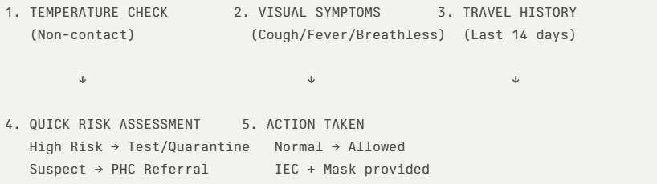
The screening protocol shall include temperature screening, observation for visible symptoms, and inquiry regarding recent travel or exposure history. Individuals identified as suspects during screening shall be immediately referred to the nearest PHC/FHC for further evaluation, testing, and appropriate action as per prevailing guidelines.

Pandemic Control Room
The Pandemic Control Room (PCR) serves as the central nerve center for real-time coordination, data aggregation, decision support, and communication during outbreaks. It consolidates information from all LSGD teams, health facilities and community sources to enable rapid response decisions.

Control Room Infrastructure and Location
Primary Location: Arattupuzha Panchayath Office.
Backup Location: Community Hall in NTPC HALL Arattupuzha

Health System Control Room Framework
The PCR is organized into seven functional pillars to ensure no aspect of the response is overlooked:

Rapid Response Team (RRT)
  - Provides immediate intervention during emergencies, clusters, and field alerts.​
  - Coordinates urgent actions such as case investigation, contact tracing, isolation, and inter‑facility referrals.

Data Management & Analytics Team
  - Collects, validates, and manages key health system indicators (cases, tests, beds, HR, supplies).​
  - Analyzes data trends, generates projections, and supports evidence‑based decision‑making for local authorities.

Human Resource Deployment Team
  - Allocates healthcare staff efficiently based on workload and need
  - Ensures adequate and equitable workforce distribution across facilities

Laboratory Surveillance Team
  - Oversees diagnostic testing coordination, sample transport, and timely reporting of results.​
  - Monitors lab indicators (testing volume, positivity rate, turnaround time) for early detection of outbreaks

Vaccination Cell (If Required)
  - Plans and executes vaccination campaigns, including micro‑planning and session scheduling.​
  - Tracks coverage, identifies gaps, and coordinates corrective actions with field teams and outreach services.

Infrastructure & Patient Occupancy Team
  - Monitors facility capacity, earmarked beds, oxygen and critical care resources across all linked facilities.​
  - Ensures optimal patient distribution and referral management using updated bed‑status and resource data.
  - BMWM

Communication team
- Logistics and supply chain
- Transportation (interfacility & emergency transport)
- Media surveillance Call centre
- Management of the deceased
- Intersectoral coordination and convergence

Key Control Room Team
The Control Room Team coordinates all pandemic response activities within the LSGD and serves as the single command and communication hub during activation. It integrates information, field actions, logistics, and policy execution across all participating departments and health facilities.

Role | Name | Designatio n | Contact Number | Responsibility
In-charge/Nodal Officer | Dr.Sherin | MO | 9995399960 | Overall coordination, decision-making, and reporting to the District level.
Data Entry Operator | 0 | 0 | 0 | Managing the line list, updating dashboards, and tracking testing results.
Communication Officer |  |  |  | Handling the public helpline, coordinating ambulance dispatch, and contact tracing calls.
Logistics  Coordinator | Mrs.Lekha | HI | 9747400896
Technical Support  (IT/Data) | Mrs.Vishnupriya | DM | 6282265594 | Managing the line list, updating dashboards, and tracking testing results.

SOP for alert escalation/trigger point with mapping of responsibilities.
Key Points:
- The Control Room shall be staffed with a designated In-charge, data entry personnel, and communication staff with clearly defined roles and shift arrangements.
- It shall maintain updated records on daily monitoring indicators including new cases, persons under active quarantine, and hospital bed occupancy.
- All reports and situation updates shall be shared daily with the Block and District Surveillance Unit.
- The Control Room shall act as a single point of contact for coordination with response teams, health institutions, and other departments.
- Contact details of the Control Room shall be widely communicated to field staff and stakeholders during activation.

Daily Monitoring Indicators
To ensure timely decision-making and effective response, the following key indicators shall be monitored and updated on a daily basis by the Pandemic Control Room:

Epidemiological Indicators:
New cases reported today, Total active cases, Test Positivity Rate (TPR), Case Fatality Rate (CFR)
- Surveillance Indicators:
Persons under home quarantine, High-risk contacts identified, Fever, ILI, SARI or other symptoms (syndromic surges), Travellers (symptomatic or high-risk arrivals),Animal husbandry surveillance (zoonotic alerts, unusual animal deaths, poultry/bird flu signals), Mortality surveillance (excess deaths, unexplained fatalities, verbal autopsy reports)
- Logistics and Infrastructure Indicators:
Hospital / CFLTC beds occupied, Oxygen cylinders/concentrators available, Ambulances on standby
- Alert Findings
The following table outlines category-specific trigger points (red flags) from surveillance indicators and corresponding immediate actions for the Pandemic Control Room. These enable rapid response to alert findings like testing anomalies, positive cases exceeding thresholds, clusters, and WGS reports.

Category | Trigger Pophint (Red Flag) | Immediate Action
Clusters | Geographical or facility-based: 5+ cases linked to one location (office, school, street). | Declare a micro-containment zone; perimeter control and active case finding.
Testing | Sudden drop in testing volume / delay in reporting / unusual testing trends | Review the sample collection process, address lab bottlenecks, deploy additional testing teams, and notify the District Lab.
Lab | Test Positivity rate increases | Increase testing sites in that ward.
Hospital | >80% Oxygen bed occupancy | Activate backup/CFLTC beds.
Travel | Cluster of cases from a single flight/train or high-risk arrival group. | Trace all passengers in adjacent seats; implement mandatory institutional quarantine.
Animal | Mass poultry/wildlife death or unusual sickness | Notify Animal Husbandry, sample the area, and dispatch RRT for environmental sampling and zoonotic check.
Mortality | Sudden spike in home deaths or brought-in-dead (BID) cases | Audit the deaths and Active Case Search drive
Additional investigations like Whole Genome Sequencing (WGS) | Detection of a Variant of Concern (VOC) or Variant of Interest (VOI) | Implement strict micro-containment; update clinical protocols to match variant severity.

Communication of Public Health Information
A Community Communication Hub shall be established to ensure timely, accurate, and consistent dissemination of information during a pandemic. The Hub will function under the coordination of Nodal officers of the control room and act as the nodal point for public communication, risk messaging, and community engagement. It will support dissemination of official advisories, promote preventive behaviors, address rumors and misinformation, and ensure that messages reach all sections of the population through trusted local channels and leaders.

Key communicators
Channel | Responsible Person | Contact
Ward-level announcements | Panchayat Member | 9539912282
Social media | Malayala manorama  (news paper) | 7025699622
Local Cable TV/Radio | C.D net private limited company,Kayamkulam | 7907093340

- All messages disseminated through the Hub shall align with advisories issued by the Health Department and District authorities.
- Community leaders shall be sensitized to support behavior change, reduce stigma, and counter misinformation.
- Special efforts shall be made to reach vulnerable and hard-to-reach populations using locally appropriate communication methods.

Rumor Tracking: A designated volunteer will monitor local social media/WhatsApp groups daily to identify misinformation and issue official clarifications via the Communication Hub.

Coordination with District/State Authorities & Other Organisations
Effective coordination with Block, District, and State authorities is essential to ensure timely reporting, technical guidance, and uninterrupted supply of essential resources during a pandemic. The LSG shall establish clear communication channels, designate responsible officers, and adhere to prescribed reporting timelines to support coordinated public health action and efficient resource mobilisation.

Key Details:
- Nodal Officer for Reporting: BMO
- Contact Number: 9846014874
Reporting Schedule and Protocols:

To Whom | What to Report | Frequency | Nodal Person
Block PHC | Complete Situation Report (Cases, Quarantine, Beds, Screening, Deaths) | DAILY | BMO
District IDSP Unit | Outbreaks/Clusters/Unusual Events (>5 cases same ward) | DAILY | DSO
Veterinary Officer | Animal health events/Zoonotic alerts | DAILY | DistrictVeterinary Officer
State Cell | Zoonotic cross-sector events | DAILY | One health nodel officer

Supply Chain Coordination
The LSG shall coordinate closely with Block, District, and State authorities (KMSCL) to ensure uninterrupted availability of essential goods, medical supplies, and logistics during a pandemic. Supply requirements shall be assessed regularly based on case load and communicated promptly to the appropriate authorities for timely replenishment.
Key Points:
- Maintain updated contact details of District and Block nodal officers for health logistics, oxygen supply, ambulances, and essential medicines.
- Submit timely indent requests for PPE, testing kits, medicines, oxygen, and other critical supplies through prescribed channels.
- Monitor stock levels at LSGD facilities, quarantine/isolation centres, and field teams through daily stock registers and dispensing logs to prevent shortages.
- Coordinate with District authorities, Karunya/Neethi medical shops, and local purchase committees for funds allocation and emergency procurement.

- Ensure regular monitoring of dispensing registers at all facilities to track usage, expiry, and pilferage—shortages being a perennial issue requiring proactive weekly audits.

- Activate surge procurement protocols during high caseloads, leveraging local purchase powers under LSGD funds alongside state supplies.

Resource Inventory and Contacts
Resource Category | Source  (District/State/Private) | Contac t
PPE Kits/Masks/Gloves | KMSCL | 9895214070
Oxygen Cylinders/Concentrators | KMSCL | 9895214070
Medicines/Antivirals | KMSCL  Neethi Shops | 9895214070  0479-2442806
Test Kits (RTPCR/Rapid) | ICMR-KMSCL / District Lab Network | 9895214070
Ambulances (ALS/BLS) | 108 / Private | 9656018108  8606908108
Vaccines (if applicable) | State Cold Chain / District | 9495757110

Collaboration with NGOs, PPP, and CSR
To augment government efforts during a pandemic, the LSG shall collaborate with NGOs, voluntary organisations, and private sector partners through public–private partnerships and Corporate Social Responsibility (CSR) initiatives, in coordination with District authorities.

Key Points:
- Engage NGOs and community-based organisations for community outreach, awareness, and support to vulnerable populations.
- Leverage CSR support for procurement of medical equipment, PPE, oxygen concentrators, food kits, and sanitation materials, as permitted.
- Ensure all collaborations align with government guidelines and are routed through approved administrative and financial procedures.
- Maintain transparency and documentation for all external support received and utilised.
Organization | Type | Support Offered | Contact Person
Youth Clubs/Student Unions | CBO | Secretary | 9087456673

Interdepartmental Coordination
Coordination among departments during a pandemic shall be ensured through regular review meetings convened by the LSGD President. These meetings will provide a structured platform for sharing situational updates, assessing resource availability, resolving operational gaps, and taking joint decisions to ensure a coordinated and timely response.

Department | Representative | Key Role | Contact
Health (PHC) | MO | Case management | 9995399960
Veterinary | Vetenarian surgen | Animal surveillance | 9747332178
ICDS | Superviser | Nutrition support | 8956473246
Education | EDC | School coordination | 8966445355
Police | SI | Containment enforcement | 0479-2430629
Fire/Rescue | Inspector | Disinfection support | 0479-2442101
Water Authority |  | Water supply | 0471-2324903
LSGD  Engineering | AE | Quarantine infrastructure | 9400958652

PHASE 3 - Surge Capacity
Phase 3 is activated when there is a rapid increase in cases, high test positivity rates, or when existing health facilities and quarantine arrangements approach saturation. The focus of this phase is to expand isolation capacity, augment clinical care services, and mobilise additional resources through district and state support mechanisms.
.

Recovery and rehabilitation phase
- Recovery
  - Damage & impact assessment
  - Restoration of health services
  - Rehabilitation of affected population
  - Psychosocial & mental health support
  - Disease surveillance during recovery phase
  - Environmental cleanup & sanitation
  - Livelihood restoration
  - Community engagement & confidence building
  - Documentation & after-action review
  - Lessons learned & best practices
  - Health system strengthening
  - Policy revision & preparedness enhancement
  - Research

CONCLUSION
This Pandemic Preparedness Plan outlines a comprehensive, decentralised, and action-oriented framework for preparedness and response at the LSGD level. By adopting a One Health approach and strengthening coordination between the health system, local self-government institutions, veterinary services, and community networks, the LSGD aims to ensure early detection, rapid response, and effective containment of pandemics and public health emergencies.
The plan emphasises equity, community participation, and evidence-based decision-making to protect vulnerable populations and ensure uninterrupted access to essential services during crises. Regular updating, mock drills, and interdepartmental coordination will be critical to maintaining readiness and resilience.
This document shall serve as a living operational guide, to be activated during alerts and continuously improved based on evolving risks, lessons learnt, and guidance from higher authorities.

"Together for a Healthier and Safer Community."

Additional points
- tech support
- relief based commodities
- ham reading operators
- hazard vulnerability mapping
- Kseb & other power source
- HR specific responsibility

RECOMMENDATIONS

Strengthening Healthcare Infrastructure
- Establish a primary health response unit within the Panchayat with trained staff.
- Ensure availability of basic medical supplies (masks, sanitizers, PPE kits, oxygen cylinders).
- Create tie-ups with nearby hospitals in for emergency referral and transport.

2. Community Awareness & Education
- Conduct regular awareness campaigns on hygiene, vaccination, and preventive measures.
- Use local communication channels (community radio, WhatsApp groups, notice boards) to spread verified information.
- Train volunteers to act as health ambassadors in each ward.

3. Emergency Response & Coordination
- Form a Pandemic Preparedness Committee at Panchayat level including health workers, ward members, and NGOs.
- Develop a clear action plan for lockdowns, quarantine, and distribution of essentials.
- Maintain a database of vulnerable groups (elderly, differently-abled, chronically ill) for targeted support.

4. Supply Chain & Food Security
- Identify and support local suppliers and farmers to ensure uninterrupted food supply.
- Create community kitchens during emergencies to serve vulnerable populations.
- Stockpile essential commodities in Panchayat-run outlets for crisis periods.

5. Digital Preparedness
- Promote digital platforms for telemedicine consultations.
- Use Panchayat’s website/social media for real-time updates on health advisories.
- Encourage online grievance redressal to reduce crowding in offices.

6. Training & Capacity Building
- Organize mock drills for pandemic response in schools, offices, and public spaces.
- Train Panchayat staff and volunteers in first aid, infection control, and crowd management.
- Collaborate with NGOs and health departments for capacity-building workshops.

7. Long-Term Resilience
- Integrate pandemic preparedness into the Panchayat Development Plan.
- Allocate a dedicated budget for health emergencies.
- Encourage community participation in planning and monitoring preparedness measures.

MOCKDRILL SCENARIOS
Emergency health care workshop conducted.
Fire and safety workshop conducted.
ANNEXURE

IMPORTANT PHONE NUMBERS

Phone numbers and particulars of persons responsible for providing guidance, assistance, and support for pandemic preparedness operations may be provided here in a manner that allows easy reference at a glance. The information recorded here could be exhibited elsewhere at the time of emergencies. LSG institutions shall give special attention to collect and record the above data of persons and institutions who/which are supposed to give technical and co-ordination support to reduce the
impact of pandemic.

  - Details of grama panchayat wards

Sl. No | Ward  number | Name of the ward  member | Contact number
- 1 | 1 | Aneesh.S | 9544930397
- 2 | 2 | lekshmi.P | 9497203169
- 3 | 3 | Ajitha.M | 9656097836
- 4 | 4 | Semasuni | 9744829646
- 5 | 5 | Rajeshkuttan | 9961589860
 | 6 | Priya | 9526305459
 | 7 | M.Prathapan | 9947829397
 | 8 | Priyarajan | 9744112617
 | 9 | Jaya Manu | 9496986315
 | 10 | Latha Thulasidas | 8304020195
 | 11 | Syamkumar.S | 9496686937
 | 12 | Binusivarajan | 8891512677
 | 13 | Prasantha | 8590410819
 | 14 | Aneesh .U | 9946171218
 | 15 | Remya Jyothy | 9747520197
 | 16 | Sulphi Thaha | 9847206820
 | 17 | Mymoonath | 9539912287
 | 18 | Thajumudheen .A | 9605232287
 | 19 | Shyma Sajan | 9961874729

  - Other important phone numbers of grama panchayat/municipality/corporation area

Sl.  No. | Name | Contact number
1. | MP | 9447199318
2. | MLA | 9447777100
3. | Collector (head of District Disaster Management Authority) | 0477-2251720
4. | Tahasildar | 0479-2302216
5. | District Panchayat Secretary | 04772252496
6. | Block Panchayat Secretary | 8113044675
9 | Forest department | Nil

  - Important oﬃces of grama panchayat/municipality/ corporation

Sl.No | Name of the oﬃce | Contact person | Contact number
1. | Village Oﬃce | VO-Manzoor | 8547611607

2. | Agriculture Oﬃce | Najitha | 9383470641
3. | Animal Husbandry Oﬃce | Ward-13 | 9747332178
4. | Police Station | Nil | Nil
5. | BSNL Oﬃce | Nil | Nil
6. | Block Oﬃce | Muthukulam | 0479-2472044
7. | KSEB Oﬃce-ward 15 | Oversear/prasad | 9447185520
8. | Fisheries Oﬃce | Subcentre  kallikkad (w-15) fathima | 9656508042
9. | Fire and Rescue | Nil | Nil
 | Coastguard | Najeeb  Ward-16 | 9447486190
10. | Money Exchanges | Nil | Nil

  - Health Services

Sl. No | Name of the hospital/institution | Location | Phone number
1. | Government hospitals/PHC | 16 | 0479-2488201
2. | Private hospitals | 13,1 | 8156825010
3. | Clinical laboratories | 16 | 8606084860

4. | Chemist/pharmacy | 2 | 9744153151
5. | Blood donors | 0 | 0
6. | Other language experts (Bihari, Hindi, Bengali,  Asamees ………) | 0 | 0

  - Veterinary Services

Sl. No | Name of the Clinic | Name of the Surgeon/Doctor | Place/loca tion | Phone number
1 | Veterinary Clinic | Dr.Ambika | Ward-13 | 9747332178
2 | Veterinary Subcentre |  | Ward-1 | 9505500360
 | Name of the shelter | Name of the Manager | Place/locati on | Phone number

  - Helpline numbers

Helpline | Phone number
Police | Nil (0479-2482026 thrikkunnappuzha)
Fire and Rescue | Nil (Kayamkulam/harippad)
Chemical factories | Nil (near next block NTCP-NOT WORKING NOW)
Blood Banks | Nil

  - Public and Private Schools Contact details
S.No | Name of School | Phone number
1 | GHS MANGALAM | 9809180036
2 | GHSS MANGALAM | 9446440903
3 | GHS VALIYAZHEEKAL | 9745893766
4 | GHSS VALIYAZHEEKAL | 9995963312
5 | ST.SEBASTIAN LPS KALLIKKAD | 9544637983
6 | GLPS NALLANIKKAL | 9847349908
7 | MLPS ARATTUPUZHA | 9188756913
8 | MUUPS ARATTUPUZHA | 9497787072
9 | SKV LPSPANAIKKAL | 8606571419
10 | SKD UPS KURIYAPPASSERIL | 9495872866
11 | SSVM RESIDENTIAL CENTRAL SCHOOL | 7510738015
12 | GURUDEVA TRUST CENTRAL SCHOOL | 94475595764
13 | ST.JOSEPH ENGLISH MEDIUM SCHOOL | 9539248715
14 | GLPS ERUVA | 7034124592

  - Anganwadi Contact Details
S.No | Name of Anganwadi | Phone number
 | Mangalam w-18 | 9562233039
 | Mangalam w-1 | 9747193266
 | Mangalam w-1 | 9946010635
 | Karthika jn w-17 | 9747555765
 | Pathissery w-18 | 8593037062
 | Arattupuzha w-15 | 9605999735
 | Arattupuzha w-17 | 8129012025
 | Kunnumpuram w-16 | 9747965317
 | Kallikkttu w-14 | 9745586079
 | AKG Nagar w-14 | 9447809032
 | Shivaji nagar w-13 | 9847481353
 | Kallikkadu w-12 | 9656684574
 | Nallanickal w-12 | 85090344039
 | Perumbally w-9 | 9656684574
 | Ramanchery w-10 | 9847481353
 | Vattachal w-11 | 7510139029
 | Tharayilkadavu w-7 | 8157887792
 | Tharayilkadavu w-7 | 8547788403
 | Tharayilkadavu w-8 | 9747986895
 | Vattachal w-11 | 9400463726
 | Pattolimarket w-4 | 9605004130
 | Vettathukadavu w-3 | 8281379831
 | Kanakakunnu w-3 | 8592011718
 | Choolatheruvu w-3 | 9744319096
 | Mahadevikad w-2 | 9605153584
 | Mangalam w- 1 | 9400481372
 | Kallikkadu w-13 | 9061701654
 | Perumbally w-8 | 9497633281
 | Valiyazheeckal w-6 | 9744162137
 | Pillakadavu w-2 | 8547456248
 | Choolatheruvu -2 | 9847297258
 | Mallikatukadavu w-4 | 9645042928
 | Kochide jetty w-5 | 9645187991
 | Tharayilkadavu w-8 | 7994927477
 | Perumbally w-10 | 9656814254
 | MES Arattupuzha w-16 | 974453714
 | Manavelikadavu w-5 | 8281222069
 | Komaly kayalvaram w -5 | 9995732055

Information regarding resources

Means of transportation | Name of Owner | Phone Number
JCB | Mineesh | 9656589451
 | Sinder lal | 7025512521
Crane | - | -
Heavy Trucks | - | -
Tractor | Sajeer(ward 16) | 7559008933
Ambulances | syam | 8876556342
Mobile mortuaries | Jomons (ward 17) | 8156819215
Boats | Sajeer | 7559008933
Taxi service | Najmudheen | 9656220006

SPECIAL INFORMATION

1.13 LOCAL MEDIA INFORMATION
S.No | Name | Phone number
1 | (Local channel)Kayamkulam CD net pvt limitted company | 07907093340
2 | News paper -local  Malayala manorama | 7025699622

1.15 DHEEVARA/ARAYA SAMAJAM (FISHERMEN COMMUNITY)

S.No | Name | Phone number
1 | Shaji | 7306523469

